Homework
Wallpaper Application

Info
- The application will be a very basic wallpaper app. Powered with high quality wallpaper api named Unsplash/Pixabay.
- Unsplash API Documentation (https://unsplash.com/documentation#libraries)
  - https://api.unsplash.com/photos/?client_id=_ClientKey_&page=_pageNumber_
  - https://api.unsplash.com/search/photos?client_id=_ClientKey_&page=_page_&query=_searchTerm_
- Pixabay API (https://pixabay.com/en/service/about/api/)
  - https://pixabay.com/api/?key=_clientKey_&page=_pageNumber_&image_type=photo
  - https://pixabay.com/api/?key=_ClientKey_&page=_page_&q=_searchTerm_&image_type=photo"

Requirements
App has two views.

First View – List of pictures (7 points)
- First View is list view (TableView, CollectionView, GridView, RecyclerView...). There will be rows, which is loading the image data into cells, from the unsplash/Pixabay API. (2 points)
- When The User pulls the list down, More images will be shown on same that list (1 point).
- New images are always on the top of the list. You can set pull to refresh function also. (1 point)
- Rows have randomly different height sizes. It will be random. Please check the images below and video demo (1 point)
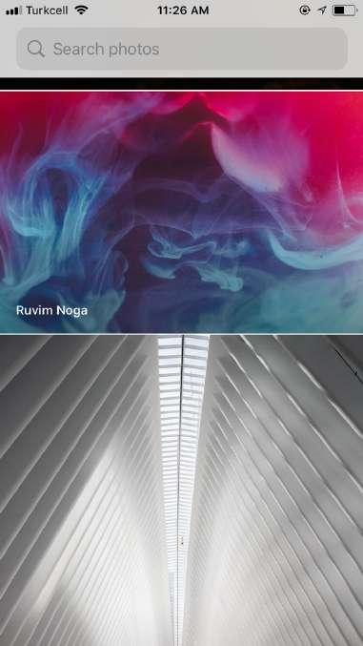
- You can put a search function. (Unsplash/Pixabay API has search function) (2 points)

Second View - Detail view (2 points)
Display image and there are 4 buttons:
Button 1 – Back button
Button 2 – Save Image (Its saving the current image to the camera roll, photos…)
Button 3 – Share image (Share image to other apps)
Button 4 – Full screen or not full screen.

Some Advanced features, Nice UI…(1 point)

